

**Faculty of Food and Biochemical Technology**

**Department of Food Analysis and Nutrition**

***LABORATORY OF INSTRUMENTAL METHODS IN FOOD ANALYSIS***

**Coupling bioanalytical assays to smartphone-based devices in food analysis**

*by Aris Tsagkaris M. Sc., Ph.D.*

# SCOPE AND OBJECTIVES

This exercise aims to introduce fundamental principles on bioanalytical assays and the novel opportunities introduced by their hyphenation to smartphones. The exercise objectives are to:

1. Understand biorecognition concepts by using immuno- and enzyme-assays.
2. Calculate and understand the meaning of half maximal inhibitory concentration (IC50) and cross-reactivity.
3. Understand the importance of using multidisciplinary approaches in food analysis, by using computer aided design (CAD) software and 3D-printing.
4. Perform smartphone-based analysis, a novel approach with great potential in the food analysis field.

# OUTLINE

|  |  |
| --- | --- |
| **PART** | **Topic** |
| A | Acetylcholinesterase (AChE) microplate assay |
| B | Paper-based assays |
| C | Lab-on-a-chip devices: CAD design and 3D-printing |
| D | Smartphone-based analysis |

# THEORITICAL PART

According to Commission Decision 2002/657/EC “screening methods are used to detect the presence of a substance or class of substances at the level of interest”. In this way, there are several methods fit within this concept able to achieve rapid, selective, cost-efficient and sensitive screening in the food safety field. In the following paragraphs, an insight on various methods is provided aiming to discuss state of the art applications and advancements.

1. *Classic biochemical assays*

Firstly, biochemical assays using antibodies or enzymes as recognition elements have been traditionally used in a microplate format, which provides high-throughput, simplicity, good sensitivity and ease of operation. The enzyme linked immunosorbent assay (ELISA) is a striking example of such bioassays. ELISA is based on the specific interaction between an enzyme labelled analyte specific antibody and its antigen. Owing to the labelling of the antibody with an enzyme, upon the addition of a substrate a measurable color change is initiated. A recent review by L. Wu et al. [1] is recommended for a deeper understanding of ELISA mechanism, various types as well as recent advances. In terms of cholinesterase microplate assays, these have been utilized in carbamate (CM) and organophosphate (OP) screening as these pesticide classes inhibit cholinesterase activity. Considering that, in vitro, cholinesterases hydrolase colorless substrates to colored products, the presence of CMs and OPs can be correlated to a color decrease similarly to competitive ELISAs. A great variety of substrates (Fig. 1), resulting in different colored products, have been used including acetylthiocholine and butyrylthiocholine halides, for AChE and BChE respectively, indoxyl acetate, α-naphthyl acetate, 2,6-dichloroindophenol acetate and others [2]. Importantly, reduced sample and reagent consumption (typically less than 100 μL) as well as low LODs at the part per billion level [3,4], depending on the matrix, were achieved by cholinesterase microplate assays.

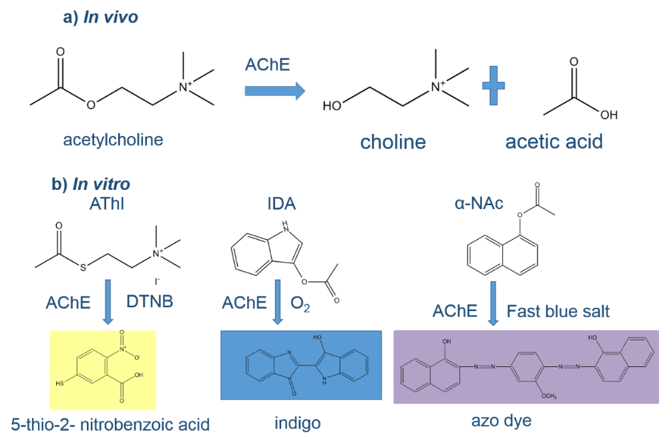

**Fig. 1** (a) In vivo, the neurotransmitter acetylcholine is hydrolyzed to choline and acetic acid by AChE; (b) In vitro hydrolysis of various substrates (acetylthiocholine iodide (AThI, Ellman’s assay substrate), indoxyl acetate (IDA) and α-naphthyl acetate (α-NAc)) by AChE producing different colored products. Reproduced under CC BY 4.0 from <https://www.mdpi.com/2076-3417/10/2/565>.

1. *Point-of-care diagnostics in food analysis*

Besides classic biochemical assays, portable and miniaturized analysis has drawn an ever-increased attention as it is related to unprecedented attractive features such simplicity, rapidness or cost-efficiency. Such methods can be clustered under the term point-of-care (POC) diagnostics including, but not limited to, lateral flow (LF) and dipstick assays, microfluidic paper-based analytical devices (μPAD) or lab-on-a-chip (LOC) prototypes. Initially inspired by needs related to the medical field, e.g. testing at remote places or low-cost diagnostics for developing countries, medical POC diagnostics have been developed based on the “ASSURED” principles. This stands for Affordable, Sensitive, Specific, User-friendly, Rapid and robust, Equipment-free and Deliverable to end-users [5]. Reasonably, this breakthrough in medical analysis initiated research effort to implement the POC concept in the food [6] and water [7] analysis. However, food POC diagnostics are in infancy stage mostly due to the analytical challenge set by complex food matrices, which mostly need exhaustive sample preparation, limiting point-of-need testing and end-user implementation. In the following paragraphs, important assets on POC diagnostics are discussed.

*2.1 Membrane-based assays*

LF assays are probably the most used POC diagnostic in the food analysis field. In principle, a LF consists of various zones of polymeric strips on which various substances can be accommodated and react with an analyte [8]. Antibodies are commonly exploited as biorecognition elements and immobilized on two different spots, the test and the control line. The control line is used as an internal quality control necessary to verify that the LF is functional. Importantly, liquid samples or extracts containing an analyte move through this lateral device due to capillary forces. Two different formats of LF assays can be distinguished, namely competitive and sandwich formats (Fig.2). Competitive assays are used for low molecular weight analytes and a positive result is related to the absence of a control line due to the blocking of antibody binding sites to protein-conjugates by the analyte. In terms of big molecules, for example allergens, the sandwich format is used and the analyte is immobilized between two complementary antibodies. It is important to notice that in the near past, result evaluation was mainly made through virtual inspection. However, the utilization of smartphones has alternated this condition, as result semi-quantification can be achieved without the need of bulky readers.

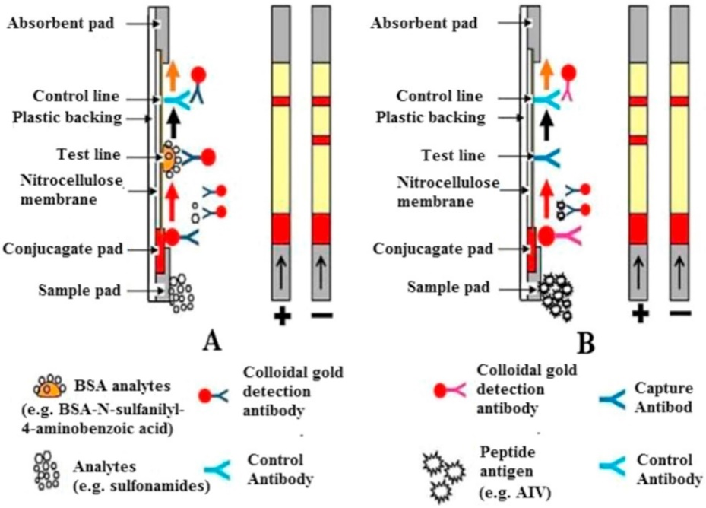

**Fig. 2.** Illustration of different LF formats, specifically a) a competitive format and b) a sandwich format. The lower line is the “test” line, and the upper line is the “control” line, reproduced with permission from [9].

Regarding paper-based assays, they provide facility, portability, cost-effectiveness, eco-friendliness and rapidity. In fact, paper is a cellulose membrane on which it is possible to immobilize a wide range of (bio)-receptors [10] such as antibodies, enzymes or aptamers that are able to selectively and sensitively detect analytes. To achieve that, various immobilization strategies [11], e.g. physical adsorption or covalent binding can be used, which are related to different advantages and drawbacks. Physical adsorption protocols are easy requiring minimal experience to apply them, but a long shelf life is not always achieved as the recognition elements may not be sufficiently adsorbed. On the other hand, covalent binding can achieve better binding of receptors on cellulose surfaces. Nevertheless, a stronger binding may affect the activity of a recognition element, for example by alternating the active site of an enzyme, thus decreasing the attainable analytical signal.

*2.2 Lab-on-a-chip technology and 3D-printing*

Despite considering automated and miniaturized analytical methods was not realistic in the near past, the introduction of LOC into food analysis has brought novel capabilities. LOC can carry out some or even all stages of an analytical protocol, e.g. sample injection or mixing, and attain rapid results due to the high surface to volume ratio which is achieved. LOC devices can be pocket size accommodating laboratory functions on a chip with cm-dimensions. Therefore, reagent consumption is minimal, typically at the μL level, resulting in less waste generation.

In terms of such device fabrication, they can be cost-efficiently fabricated using additive manufacturing (AM) or, as it is widely known, 3D-printing. AM is a process that creates a physical object from a digital design, which was developed using computer aided design (CAD) or a CAD software. According to the American Society for Testing and Materials (ASTM), “AM refers to a process by which digital 3D design data is used to build up a component in layers by depositing material”. The printing is performed by adding layer-upon-layer of a material using various types of AM technologies. A comprehensive overview on the process from the virtual CAD description to the physical resultant part can be found in [12] and is recommended for a deeper understanding while Fig. 3 provides a general overview of an AM workflow.

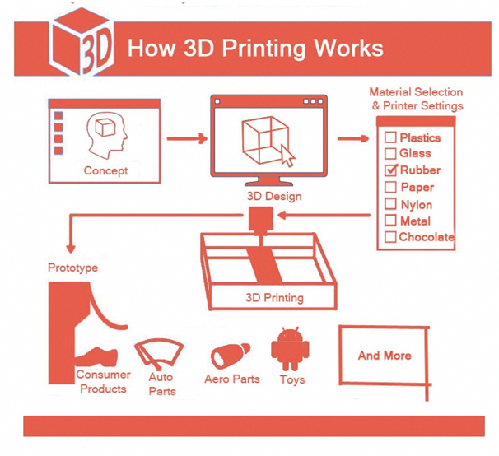

**Figure 3.** The generic AM process, source: [www.pinterest.ie](http://www.pinterest.ie), last accessed 21/9/2020.

1. *Smartphone-based analysis: state of the art and challenges*

POC diagnostic potential can be further enhanced by coupling them with smartphones to achieve ubiquitous monitoring [13]. Real-time one-click results due to smartphone apps, online connectivity, geo-temporal mapping or potential end-user implementation are among the merits that smartphone utilization brings. POC methods with smartphone readout can provide personalized results and initiate a paradigm shift by intensifying testing. In terms of food analysis, pre-screening of food with POC will result in laboratory-based testing only for suspected samples. Therefore, rapid results will lead to a better utilization of available recourses and introduce to the general public the importance of food testing, a process commonly forgotten or underestimated. Indeed, the hyphenation of POC diagnostics to smartphones is a step towards the “democratization” of chemical analysis and the introduction of new era, in which sensing is not strictly related to laboratories. Further information and insight on the topic can be found in our review paper [14].

There are still challenges regarding the performance of POC diagnostics coupled to smartphones. To begin with, to achieve a truly personalized monitoring, acquired results should not be affected by the use of any smartphone model. However, this is not the case; the majority of developed smartphone-based assays are applicable only when using certain smartphones. Besides, lot of controversy has been around regarding image data acquisition and processing when using a smartphone readout. Although electrochemical detection is also used, optical detection is more preferable and convenient so far as the smartphone camera can be used to record images or videos. In terms of data acquisition, it has not been clear so far whether is necessary to use auxiliary attachable parts such as 3D-printed elements to standardize optical conditions or record under ambient light. Various data processing approaches have been developed using the RGB color space (the primary color space in which smartphones capture images by default) or transforming the original signal to other color spaces (HSV or CIE-Lab) or to barcodes [15]. Except the smartphone readout, one should always keep in mind the importance of developing rugged and sensitive POC diagnostics. In fact, there were cases in which insufficient validation was noticed or the performance in matrix was significantly decreased. More about this problem can be found in our publication [16].

References

[1] L. Wu, G. Li, X. Xu, L. Zhu, R. Huang, X. Chen, Application of nano-ELISA in food analysis: Recent advances and challenges, TrAC Trends Anal. Chem. 113 (2019) 140–156. https://doi.org/https://doi.org/10.1016/j.trac.2019.02.002.

[2] E. Halámek, Z. Kobliha, V. Pitschmann, Analysis of chemical warfare agents, Univerzita obrany, 2009.

[3] X. Yang, J. Dai, L. Yang, M. Ma, S.-J. Zhao, X.-G. Chen, H. Xiao, Oxidation pretreatment by calcium hypochlorite to improve the sensitivity of enzyme inhibition-based detection of organophosphorus pesticides, J. Sci. Food Agric. 98 (2018) 2624–2631. https://doi.org/10.1002/jsfa.8755.

[4] M. Pohanka, J. Zdarova Karasova, K. Kuca, J. Pikula, Multichannel spectrophotometry for analysis of organophosphate paraoxon in beverages, Turkish J. Chem. 34 (2010) 91–98. https://doi.org/10.3906/kim-0903-7.

[5] J.H. Soh, H.-M. Chan, J.Y. Ying, Strategies for developing sensitive and specific nanoparticle-based lateral flow assays as point-of-care diagnostic device, Nano Today. (2020) 100831.

[6] M.Y.-C. Wu, M.-Y. Hsu, S.-J. Chen, D.-K. Hwang, T.-H. Yen, C.-M. Cheng, Point-of-Care Detection Devices for Food Safety Monitoring: Proactive Disease Prevention, Trends Biotechnol. 35 (2017) 288–300. https://doi.org/10.1016/j.tibtech.2016.12.005.

[7] S. Kumar, M. Nehra, J. Mehta, N. Dilbaghi, G. Marrazza, A. Kaushik, Point-of-Care Strategies for Detection of Waterborne Pathogens, Sensors . 19 (2019). https://doi.org/10.3390/s19204476.

[8] K.M. Koczula, A. Gallotta, Lateral flow assays, Essays Biochem. 60 (2016) 111–120. https://doi.org/10.1042/EBC20150012.

[9] M.J. Raeisossadati, N.M. Danesh, F. Borna, M. Gholamzad, M. Ramezani, K. Abnous, S.M. Taghdisi, Lateral flow based immunobiosensors for detection of food contaminants, Biosens. Bioelectron. 86 (2016) 235–246. https://doi.org/https://doi.org/10.1016/j.bios.2016.06.061.

[10] C.I.L. Justino, A.C. Freitas, R. Pereira, A.C. Duarte, T.A.P.R. Santos, Recent developments in recognition elements for chemical sensors and biosensors, TrAC Trends Anal. Chem. 68 (2015) 2–17.

[11] E.W. Nery, L.T. Kubota, Evaluation of enzyme immobilization methods for paper-based devices—A glucose oxidase study, J. Pharm. Biomed. Anal. 117 (2016) 551–559. https://doi.org/https://doi.org/10.1016/j.jpba.2015.08.041.

[12] I. Gibson, D.W. Rosen, B. Stucker, Additive manufacturing technologies, Springer, 2014.

[13] J. Nelis, C. Elliott, K. Campbell, “The Smartphone’s Guide to the Galaxy”: In Situ Analysis in Space, Biosensors. 8 (2018) 96.

[14] J.L.D. Nelis, A.S. Tsagkaris, M.J. Dillon, J. Hajslova, C.T. Elliott, Smartphone-based optical assays in the food safety field, TrAC Trends Anal. Chem. 129 (2020) 115934. https://doi.org/https://doi.org/10.1016/j.trac.2020.115934.

[15] J. Guo, J.X.H. Wong, C. Cui, X. Li, H.-Z. Yu, A smartphone-readable barcode assay for the detection and quantitation of pesticide residues, Analyst. 140 (2015) 5518–5525. https://doi.org/10.1039/C5AN00874C.

[16] A.S. Tsagkaris, J.L.D. Nelis, G.M.S. Ross, S. Jafari, J. Guercetti, K. Kopper, Y. Zhao, K. Rafferty, J.P. Salvador, D. Migliorelli, G.I.J. Salentijn, K. Campbell, M.P. Marco, C.T. Elliot, M.W.F. Nielen, J. Pulkrabova, J. Hajslova, Critical assessment of recent trends related to screening and confirmatory analytical methods for selected food contaminants and allergens, TrAC Trends Anal. Chem. (2019) 115688. https://doi.org/https://doi.org/10.1016/j.trac.2019.115688.

# EXPERIMENTAL PART

**Part A. AChE microplate assay**

The potential dietary intake of CM and /or OP residues poses a threat for human health due to their neurotoxicity. However, unless sophisticated laboratory instrumentation is available, then controlling residues is in most cases a rather difficult task. On this account, we developed a rapid, simple and cost-effective method capable to detect CMs and OPs in food matrices. During this exercise, critical assay parameters such as enzyme substrate and enzyme specificity towards different inhibitors were tested.

*Apparatus & Software*

* Absorbance measurement in an Epoch Biotek Reader
* 96-microwell plates
* Graph-pad Prism 5.0

*Chemicals & Reagents*

* Phosphate buffer saline (PBS) tablets
* AChE from Electrophorus electricus, acetylthiocholine iodide (AThI, purity >99%), 5,5′-dithio bis-2-nitrobenzoic acid (DTNB, purity >99%) indoxyl acetate (IDA, purity >95%), a-naphthyl acetate (α-NAc, purity >98%), fast blue B salt (FBBS, purity ̴95%)
* Various CM and OP pesticides

*AChE microplate assay*

To find the most suitable AChE substrate, three different AChE assays are tested, namely Ellman’s, IDA and a-NAc assays. The respective assay protocols are listed below:

1. Ellman’s assay

Thirty μL AChE (0.009 U well-1) were incubated with 30 μL of an inhibitor for 15 min. Next, 30 μL of a 12.5 mM AThI: 1.5 mM DTNB (9:1) solution in PBS were added and the absorbance was measured at 412 nm after 2 min.

1. Indoxyl acetate assay

Fifty μL AChE (0.75 U well-1) were incubated with 50 μL of an inhibitor for 15 min. Next, 10 μL of 10 mM IDA in EtOH was added and the absorbance was measured at 670 nm after 30 min.

1. Alpha-naphthyl acetate assay

Thirty μL AChE (1.1 U well-1) were incubated with 30 μL of an inhibitor for 15 min. Next, 30 μL of 2 mM a-NAc: 0.66 mM FBBS (1 in EtOH :5 in PBS) was added and the absorbance was measured at 525 nm after 2 min.

*Specificity testing – Cross Reactivity%*

CMs and OPs have the same mode of action towards AChE, thus, it is important to evaluate AChE specificity towards the tested inhibitors. Assay specificity was evaluated in terms of cross-reactivity towards carbofuran, which was the strongest AChE inhibitor. The cross-reactivity was calculated using the half maximal inhibitory concentration (IC50) as follows:

*Cross-reactivity (%) = (IC50carbofuran / IC50pesticide) x 100, carbofuran cross-reactivity was set as 100%.*

*Carbofuran screening in apple juice*

Apple juice was purchased by the local market. Prior to the enzyme assay, the samples were analyzed by an LC-MS/MS method to verify that they did not contain detectable levels of OPs and CMs. Apple juice was diluted 10 times with PBS and the diluted samples were spiked with carbofuran to reach a concentration range from 0.078 to 5 mg L-1 and subjected to the enzyme assay.

**Part B. Paper-based assays**

*Apparatus*

* *Whatman chromatography paper*
* *Wax-printed Whatman chromatography paper*

*Chemicals & Reagents*

* Phosphate buffer saline (PBS) tablets
* AChE from *Electrophorus electricus*

*AChE immobilization*

AChE was physically adsorbed on Whatman paper strips with 1.4 x 1 cm dimensions. The immobilization procedure was simple as 10 μL of AChE working solution in PBS (0.5 U μL-1) were pipetted into a microwell of a 96-microwell plate and a strip was dipped in the well using a tweezer, resulting in 5 U AChE/strip. Afterwards, the strips were dried in room temperature for 1 h and were ready for use.

*Application of wax-printing on strips*

Demonstration of wax-printed strips and discussion on the advantages that this technology provides.

**Part C. Lab-on-a-chip devices: CAD design and 3D-printing**

*Apparatus & Software*

* Stereolithography (SLA) 3D-printer, Fused Deposition Modeling (FDM) 3D printer
* Photocurable resin for SLA printer, PLA filament for FDM printer
* Fusion 360 CAD software

*LOC device design*

A tutorial on how to design LOC devices using the free Fusion 360 CAD software is presented. For the students, it is recommended to download the software, register using their university username-password and put hands-on LOC device designing.

*3D-printing*

Demonstration of the process followed during 3D-printing using SLA and FDM printers.

**Part D. Smartphone-based analysis**

*Apparatus & Software*

* Smartphones
* In-house smartphone reader for carbofuran screening
* RIDA@SMART app for aflatoxin screening
* Hand-made smartphone reader
* ImageJ free software

*Lab-on-a-chip injector with smartphone read-out*

LOC devices are assembled using the prepared strips (from Part C). Immobilized AChE activity is measured both in the presence carbofuran insecticide (at a specified concentration level) and absence of an inhibitor (blank sample), using the Ellman’s assay which is composed of two steps. Firstly, the paper strip is incubated with a sample for 8 min and then a solution of the enzyme substrate and the chromogenic reagent (75mM BThI: 7.5mM DTNB, 9:1 (v/v), respectively) is added, and the yellow color development is monitored after 2 mins using the 3D-printed smartphone reader. Finally, demonstration of the image data processing using ImageJ free software is presented

*RIDA QUICK smartphone-based aflatoxin test*

This is a commercial smartphone-based test called RIDA QUICK Aflatoxin based on a LF immunoassay for aflatoxin screening in corn. The test uses an aqueous extraction method. More information regarding the test can be found in the link, <https://food.r-biopharm.com/products/ridaquick-aflatoxin-rqs-eco-2/>, last accessed 18/09/2020.

*Beer’s Law and Absorption Spectrophotometry with a smartphone*

The application of the Beer’s law using a handmade smartphone-based reader is demonstrated. In this way, various dilutions of a yellow food colorant (100% colorant, 75% colorant, 50% colorant, 25% colorant, 0% colorant) with deionized water will be used to construct a calibration curve. Students will use their own smartphones to take pictures of the cuvette containing the colorant solutions.

# REPORTING

**Full Name, Team**

**PART A**

1. Which is the most suitable AChE substrate and why?
2. Calculate the IC50 values of all inhibitors using this online tool, <https://www.aatbio.com/tools/ic50-calculator>
3. Calculate IC50 of carbofuran in diluted apple juice using the aforementioned tool and provide the inhibition curve.

**PART B**

1. List advantages and drawbacks of physical adsorption principle using a table format?
2. Which are the merits of using wax-printing?

**PART C**

Follow the step-by-step instructions provided to practice on the design of LOC devices using Fusion 360 CAD software (optional activity).

**PART D**

Plot a calibration curve using the recorded RGB values from your smartphones and provide the graph.

|  |  |
| --- | --- |
| colorant % | Blue channel counts (n=3 per point) |
| 0 |  |
| 25 |  |
| 50 |  |
| 75 |  |
| 100 |  |