Radiation detectors
Both experimental and operational equipment users are dependent on the detection of nuclear radiation. This detection is made possible by the interaction of ionizing radiation with the environment.

Radiation detectors can be divided into the following:
• Computers whose output is an electrical pulse that carries information about the passage of a charged particle through the measuring space of the detector
• Trajectory chambers, in which the trajectory of a charged particle is recorded, which can then be photographed or otherwise recorded.
The basic types of detectors are listed in the table. Different types of detectors provide different types of information about radiation. Some are able to determine with high accuracy the time of passage of the particle, some the location of the event, some determine the energy that the particle lost in the detector.
Detectors are characterized using the following quantities:
1. Dead time – is the time interval during which the detector cannot detect another particle after the passage of a particle
2. Detection efficiency of the device – is the probability that the radiation passing through the detector will be captured
3. Spatial resolution – determines the minimum distance between two particles that can still be distinguished as separate
4. Time resolution – determines the minimum time interval between the passage of two particles through the detector, which can still be distinguished
5. Energy resolution – indicates the relative energy difference of two particles that can still be distinguished.

Table No.1
Detector | Time resolution [s] | Dead time  [s] | Spatial resolution  [m] | Volume  [m⁻³]
ionization chamber | 10⁻³ | 10⁻² | x | 10⁻⁶ do 10⁻¹
proportional and Geiger–Műller counter | 10⁻⁶ | 10⁻⁴ | x | 10⁻⁶ do 10⁻²
scintillation computer | 10⁻⁸ | 10⁻⁶ | x | 10⁻⁶ do 10⁻²
semiconductor detector | 10⁻⁸ | 10⁻⁶ | 0,005 | 10⁻⁷
Cherenkov detector | 10⁻⁹ | 10⁻⁸ | x | 10⁻⁶ do 10⁻²
photographic nuclear emulsion | - | - | 10⁻⁶ | do 10⁻²
mist chamber | 10⁻² | 100 | 0,0005 | do 10⁻¹
bubble chamber | 10⁻³ | 1 | 5.10⁻⁵ | do 5
spark chamber | 10⁻⁶ | 10⁻³ | 0,0005 | do 1
x depends on the dimensions of the detector

Gas-filled detectors

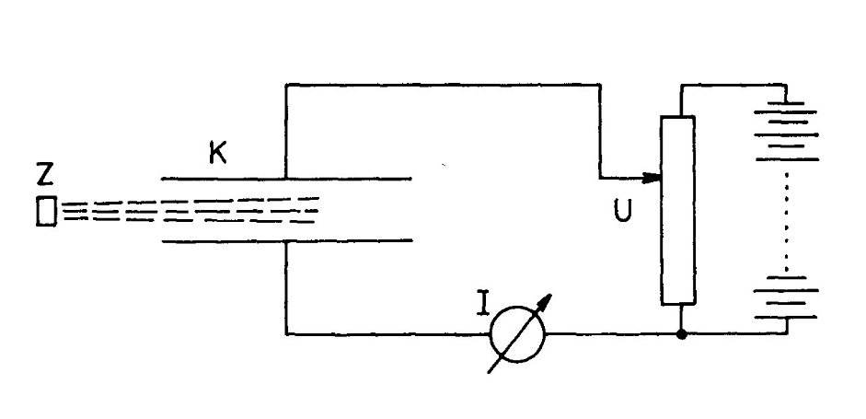

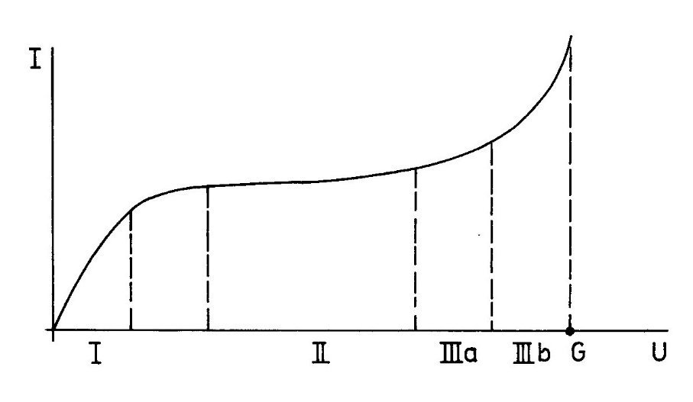

In region (I) of the validity of Ohm's law, ionization of the gas occurs, but the formed vapors mostly disappear by recombination, in region (II) of the saturated current, all formed ions are led to the electrodes, recombination is negligible. Ionization chambers work in this area. In another region of full (IIIa) and limited (IIIb) proportionality, another process, impact ionization, is added. Electrons created by primary ionization, which is caused by external ionizing radiation, acquire such energy at these voltages on the capacitor plates that they can further ionize themselves. This process increases the total number of ions and thus further increases the current, therefore this process is called gas amplification. Proportionality means the proportionality between the primary ionization by radiation and the current I. Proportional computers work in this area, which make it possible to measure the energies of particles in a certain field. The point G is called the Geiger threshold, the relevant voltage corresponding to this threshold is already so large that even a small primary ionization due to gas amplification will cause a large current growth. Geiger-Műller computers work in this area. At voltages greater than the Geiger threshold, a separate discharge occurs with any small primary ionization, which is the area of ​​operation of the spark chambers.

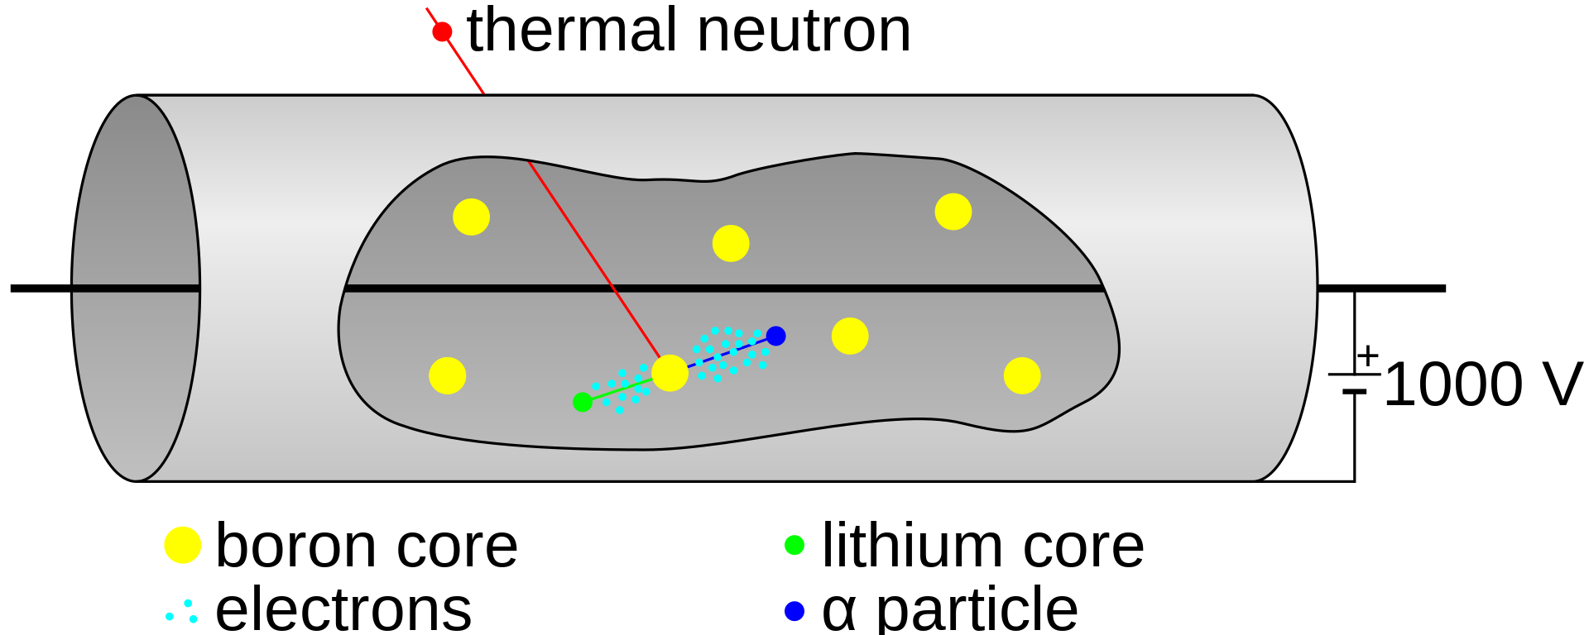

Scintillation detectors
The scintillation method is one of the oldest, since Rutherford used zinc sulfide screens in his experiments. A modern scintillation detector consists of three parts: a scintillator, a light guide and a photomultiplier. A scintillator is a substance that emits light radiation in the visible or ultraviolet region after being excited by charged particles. Scintillators can be divided into inorganic crystals, organic crystals, liquid, plastic and noble gases. Inorganic crystals and organic substances have a different mechanism of emitting light radiation, which is reflected in the length of the illumination time

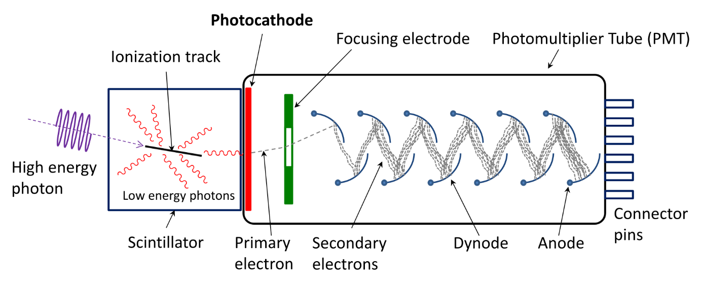

Semiconductor detectors

A charged particle can release a charge carrier also in a crystal of a solid. By diverting the generated charge carriers (i.e., in this case, electrons and holes) to the electrodes, a signal about the passage of the particle is obtained. These detectors have several advantages over gas-filled ionization chambers. There is a much larger amount of material in the sensitive volume with a solid substance, so even particles with high energy can be stopped and the detection efficiency of γ radiation is greater. These chambers also have better energy and temporal resolution due to the mobility of the charge carriers.

Cherenkov's computers
If a charged particle moves in a medium with a relative refractive index n at a speed higher than the speed of light in the given medium (c/n), a phenomenon similar to the formation of a shock wave occurs when a body moves at supersonic speed in air. However, instead of a sound shock wave, there is an emission of electromagnetic radiation in the visible light region, which was called Cherenkov radiation after its discoverers (the radiation was discovered by P.A. Cherenkov and S.I. Vavilov). These computers are based on the registration of this radiation. A Cherenkov detector consists of a block of optically transparent material with a high refractive index, called a radiator, and a photomultiplier that registers light pulses. Solid, liquid and gaseous substances with suitable optical properties are used as radiators in Cherenkov computers. So-called focused computers are also being constructed, which use the dependence of the angle of the emitted radiation on the speed of the particle. Such a detector then records only particles that have a speed in a certain interval.

Intrareactor radiation detectors

Activation detectors
fission chamber
self-powered detector
thermal sensors

Detectors for in-reactor measurement and monitoring of the radiation field in the active zone of reactors

The following four types of detectors are mainly used to detect intra-reactor radiation: activation detectors, fission chamber, self-powered detectors and thermal sensors. The increasing specific power and dimensions of the active zones of nuclear reactors and the requirements to increase the safety and economy of operation caused the necessity of measuring and evaluating the internal reactor parameters. Suitable detectors must meet a number of conditions according to the type of their purpose. These are the response speed, the influence of the surrounding environment (high temperature, high level of neutron and photon fields, high pressure, humidity and aggressive environment in the case of wet measuring probes), size (the outer diameter of the probe must not exceed 8-11 mm), reproducibility and reliability .

Activation detectors

It is a material that is activated by a nuclear reaction with a neutron, and by measuring the activity of the irradiated material it is possible to determine how it was irradiated. To measure the distribution of the neutron flux density, the activation of manganese or vanadium contained in the alloy from which the detectors are made is usually used. In the VVER 440 type 230 reactors, the activation detectors are in the form of a wire with mechanical movement. KWU power plants use the Aeroball system – activation detectors in the form of balls with a diameter of 1.7 mm, whose movement is ensured pneumatically using pure nitrogen.

Fission chamber

It is a detector that uses fission reactions to convert neutron detection to charged particle detection. Structurally, the detector is made of a stainless steel chamber, the insulation is made of Al2O3 and the fissile material is U235. The tube is the cathode, the anode is placed inside, and the gas filling is in the space between. The polarization voltage used is, for example, 150 V in French CFUF 43/P detectors. Charged particles are released from the layer of fissile material, which cause ionization in the gas filling, and the charge carriers then fall on the electrodes and cause current to flow. The loss of the measuring capabilities of the chamber is most often attributed to the degradation of the fissile material, leakage of the gas filling and mechanical damage to the connection between the cable and the fission chamber. Typical parameters are the sensitivity of the chamber (10-17 A/n.cm-2s-1 for the cited chamber), the measurement range of the neutron flux (1011 to 1014 n/cm2s , which means resulting currents in the range of 1μA to 1 mA) and the total fluence ( 1020 n/cm2).

Self-powered detectors

The self-powered detector is based on (n,β) or (n,γ) response. The detector itself consists of two coaxial electrodes, between which there is insulation. The electrodes are connected to a cable with mineral insulation. The cable sometimes also contains a compensation core to compensate for the parasitic signal arising on the supply line. When placed in a radiation field, the inner electrode emits electrons, some of which have sufficient energy to pass through the insulator. The emitter is charged positively and the measured current is proportional to the radiation parameters of the field.
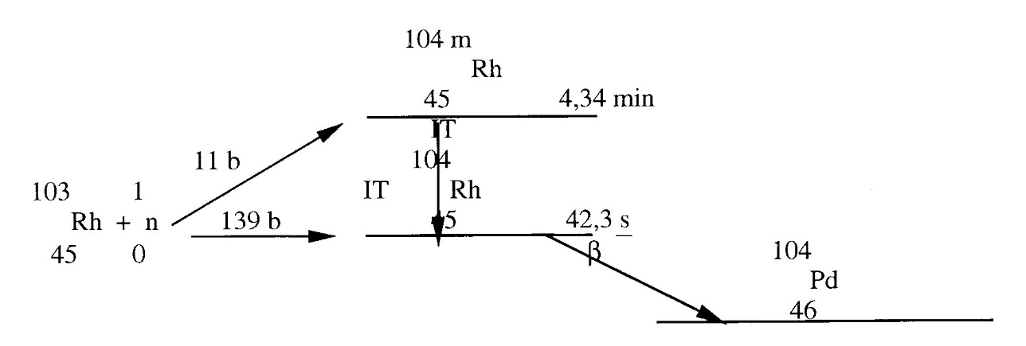
Schematic of signal generation in a self-powered detector with a rhodium emitter

Compared to other in-reactor detectors, they are characterized by several advantages:
• they do not need any power supply
• are simple and robust designs
• relatively small mechanical dimensions required for in-reactor installation
• good stability under the influence of temperatures and pressure
• generate a reproducible linear signal
• small burn-in (depending on the detector material)

But there are also some disadvantages
• limited working range due to relatively low sensitivity to neutrons
• required background noise compensation (for some emitters)
• delayed signal response (for some emitters)

The shell material is usually stainless steel or Inconel nickel alloy, the insulation is usually Al2O3, MgO or SiO2.
Beta emission self-powered detectors – with a delayed response, the emitter material is activated when placed in a neutron field, and the activated nuclei subsequently decay by beta decay. Some of the electrons produced have enough energy to leave the emitter and pass through the insulator. Typical materials for these types of detectors are vanadium, rhodium and silver. Rhodium is the most common material and emitter, and the signal generation scheme is as follows:

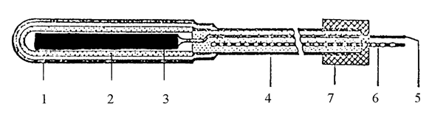
Self-powered detector
1 collector, 2 insulator, 3 emitter, 4 connecting line, 5 active vein, 6 compensation vein, 7 bushing (grommet)

Self-powered detectors with an immediate response work on the principle of the generation of captured radiation γ when a neutron is absorbed by the emitter material. The γ radiation then causes the photoeffect and the Compton effect to produce electrons capable of leaving the emitter and passing through the insulator. A typical representative of this type of detector is a self-powered detector with a cobalt emitter. The signal of this detector is instantaneous, but needs long-term compensation, as radioactive isotopes Co60 and Co61 are produced. The disadvantage of this type is relatively low sensitivity. Self-powered detectors sensitive to gamma radiation - electrons capable of leaving the emitter and passing through the insulator are created by the interaction of external γ radiation with the material of the emitter. The most used emitter material in this case is platinum. The signal is instantaneous and has two components, from γ radiation and from neutrons (93% from γ and 7% from neutrons in a typical pressurized water reactor core).

Thermal sensors (calorimeters, gamma thermometers)

Either neutron fluence input or gamma radiation is measured. The sensor consists of an absorbent body from which the heat input is led to the cooler. The generated power is determined from the temperature data measured by the thermocouples, which can be placed in different places of the assembly, usually they are used to lead the power to the cooler. Calibration of the detector is carried out outside the reactor using an electrically heated body, which is replaced by an absorption body. The absorption body can be made of different materials, enriched uranium was used for measurements on VVER nuclear reactors, and the entire measuring probe also contained one thermal sensor with an absorption body made of tungsten, which is used to determine the radiation input from external gamma radiation.

A comparison of the characteristics of the most frequently used in-reactor sensors – regenerative fission chamber (in boiling reactors), self-powered detector and gamma thermometer is shown in Table 2. Measured value – either neutron fluence input or γ radiation is measured. Typically, the neutron fluence power is measured, which characterizes the fission rate. Recently, there has been an increasing interest in measuring the fluence of γ radiation, because it shows smaller spatial changes in a nuclear reactor and thus greater accuracy can be obtained due to the uncertainties in determining the detector-fuel position. One of the objectives of the measurement is to obtain an image of the spatial distribution of the released power, and therefore the vectors of the measured data of the detector signals are processed by relatively complex computer codes. Using these calculations, local values ​​of released power are determined and extrapolated to locations in the reactor that are not monitored. If it concerns the sensitivity, or the height of the measured signal, then the measured signal of the fission chamber is usually greater than 100 μA, the signal of the self-powered detector is about two orders of magnitude lower. Gamma thermometers are designed so that the measured temperature difference is approximately 40oC, which corresponds to several mV. The speed of response to a transient in the core is particularly important if the given in-reactor sensor is part of the reactor protection system.

Table 2. Comparison of parameters of intrareactor radiation detectors
 | Fission chamber | Self-powered detector | Gamma thermometer
The number of operating detectors | 6500 | 6750 | 300
Measured value | neutron fluence input | neutron fluence input / gamma radiation | fluence input of gamma radiation
Sensitivity | 5.10-18 A/ n v | 10-20 A/ n v | 26oC/W/g
Response | immediate | immediate/delayed | delayed
Burnout /50%/ | 5.1021 n.cm⁻² | 5.1021 n.cm⁻² | -
Service life | 6 years | 5-10 years | 10 years
Calibration | relative | relative | absolute
The price of the measuring set | 1,0 | 0,4-0,8 | 1,0-1,5

https://www.sciencedirect.com/science/article/pii/S0306454917303250

