SOME PHYSIOLOGICAL PRINCIPLES OF NUTRIENTS CHANGES

Principle of homeostasis
Homeostasis – maintainance of the stable conditions in organism

Physiological controlled quantities:
- Blood pressure,
- osmotic ratios,
- pH body juices,
- Body temperature,
- Concentration of some compounds in cells and in body juices – mineral substaces,
nutrients – e.g. glucose, amino acids, lipids etc.,
outlet compounds

Homeostasis
Control:
Autonomic nervous system – via of the controlling of intrinsical organum function
Superior organum - CNS -hypothalamus
Peripheral autonomic system - sympaticus and parasympaticus
Feedback – response of controlled organum on the signal (e.g. cell ↔ hormon) retroacts the function of signal parent (beginning signal is decreased)

pH value:
- pH of blood: 7,35 – 7,45;
- stabile ratio CO2 / HCO3- ensures this value

Controlling of gastrointestinal system (GIS) function
- The controlling via CNS and / or autonomic nervous system (ANS)

- Direct controlling - reflex arch - elektrical impulse from CNS or ANS (via nervous filaments) – response from the GIS (via nervous filaments)
- Mediate controlling - adjustment organs – hormones; response via adjustment organs also

- Signal – mainly changes of substrates or metabolites concentration
- other mechanisms, e.g. psychic stress – disorders of controlling function

Changes of nutrients in the GIS
Biopolymers: digestion – hydrolysis – enzyme catalysis
Schema human digestive system and relevant glands (liver and pankreas)

DIGESTIVE JUICES
Saliva
- Enzymes: lipase; α-amylase (ptyalin)
- Time of function: chewing of food (tens seconds); deglutition (seconds); stomach repose period (some minutes)
- Digestion: fats (about 5 %); starch (about 10 %)

Stomach juice
- pH of stomach: repose period 3,5 – 5; work period 1 – 2
- HCl
- Enzyme: pepsine
- Digestion: proteins – formation of shorter polypeptide chains

DIGESTIVE JUICES - small intestine
Bile
Function - digestive and excretory
500 – 800 ml / day
Storing in gall-bladder
Composition:
pH 7,8 - 8,5
bile acids (fat emulgation)
cholesterol
colour substances (bilirubin)
salts (NaCl and other)
mucine
lecithine
DIGESTIVE JUICES - small intestine

Pancreatic juice: 1-2 litres per day

Composition:
HCO3- - hydrogen carbanate salts (pH 8,4)
trypsine
chymotrypsine proteins
carboxypeptidase
α- amylase - polysaccharides oligosaccharides
pancreatic lipase
phospholipase
ribonuclease

Small intestine juice
About 3 litres per day

Composition:
salts
water
mucine
enzyme - oligopeptidases - (peptides – amino acids)
- α- a β-glykosidase (e.g. saccharase, lactase)
- lipases
- phospholipases
- nukleosidases

Nutrients resorption – small intestine
Schema of small intestine: A – cross section; B – mucous membrane fimbria; C – schema of resorption cell (enterocyte)
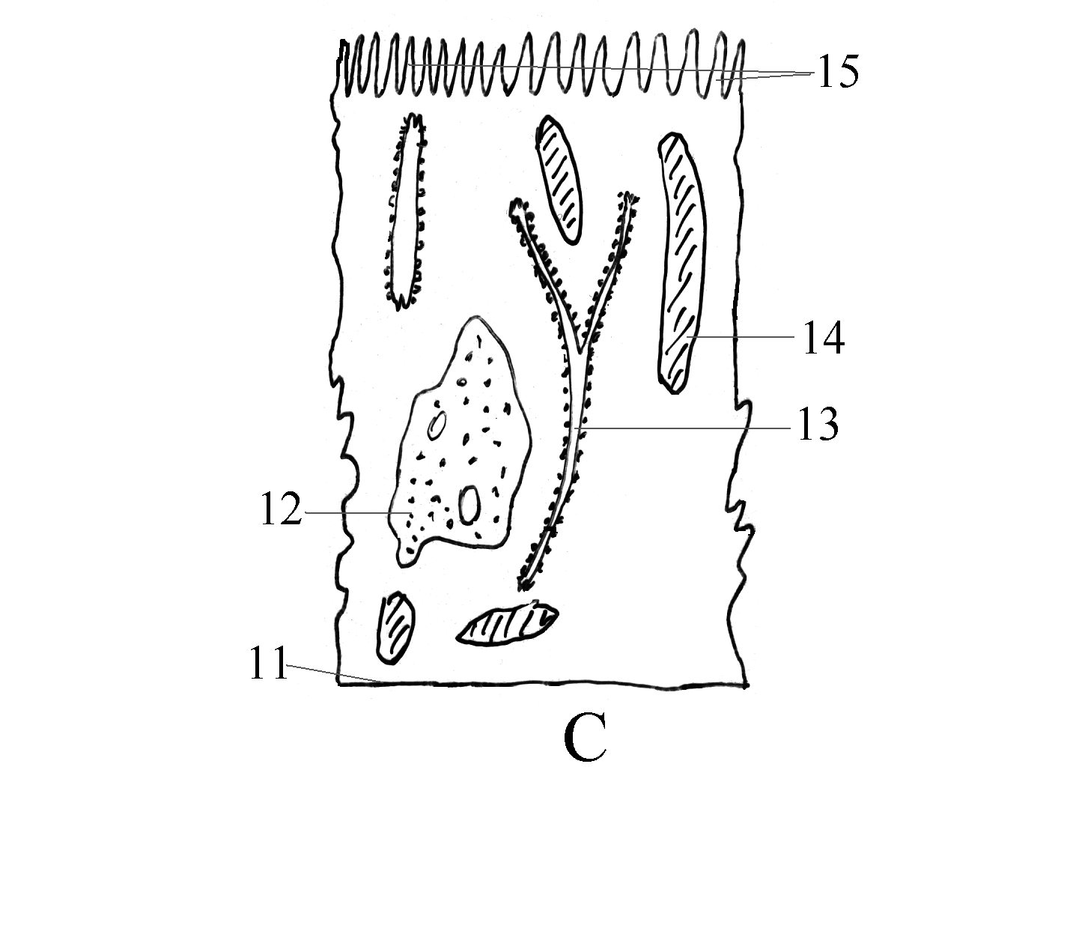
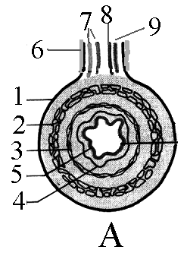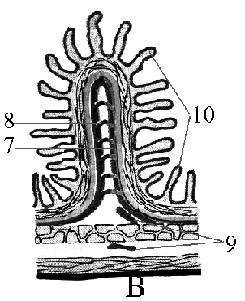1 = peritoneum (serosa); 2 = axial muscle; 3 = circular muscles; 4 = submucosa; 5 = mucous membrane (mucosa); 6 = mesenterium (supporting structure); 7 = lymphatic vessels; 8 = blood vessels; 9 = nervous systém - sympaticus and parasympaticus; 10 = villi; 11 = basal cell membrane; 12 = nucleus; 13 = intracellular membrane system; 14 = mitochondrias; 15 = microvilli

CONTROLLING OF FOOD INTAKE

Hypothalamus

System:
2 mutual connected and dependent cell systems – feed-back system – 1. centre for food abundance and 2. centre of hunger
Disorders:
- hyperphagy (bulimia) ⇒ obesity;
- anorexia ⇒ malnutrition
- Tendency to unsuitable (higher or smaller) doses of food
Activation of hypothalamic centre
- Physiologic activation –
periphere nerves autonomic nerves hypothalamus
- Activation from CNS - psychic activation – in the current population evidently have a higher importance than physiological activation

Physiological activation:
- Nervous impulses – hunger contraction of stomach
- Chemical impulses - glycaemia or lipaemia
- Physical impulses – blood temperature, outside temperature (interrelate with body temperature)

Psychical influences on the hunger sense:
Role of tendencies
- Perceptions - sensory quality of dish (taste, flavour, colour, packing, etc.) and surrounding quality also,
- Familiar rhytm of meals,
- Fixed perception and tabu,
- Psychical condition of human - stress hyperphagy, stress anorexia

CONTROLLING OF BEVERAGES INTAKE
Physiological impulses
- Osmotic ratio of inner liquids – can to change e.g. by salt intake – biggest influence,
- Changes of recirculation liquids (e.g. blood) volume – smaller influence
- Dryness of mucose in mouth and pharyngs (e.g. during lecture) - smaller stimulative influence

Psychic regulation
- Culture tendencies (e.g. after meal),
- Purposeful regulation – e.g. purposeful adherence to the health nutrition,
- Other tendencies (e.g. beer consumption)

Physiological activation have prevalent importance for current population also

